1.Join the author table with the book table,Select the title of each book and the name of its author.

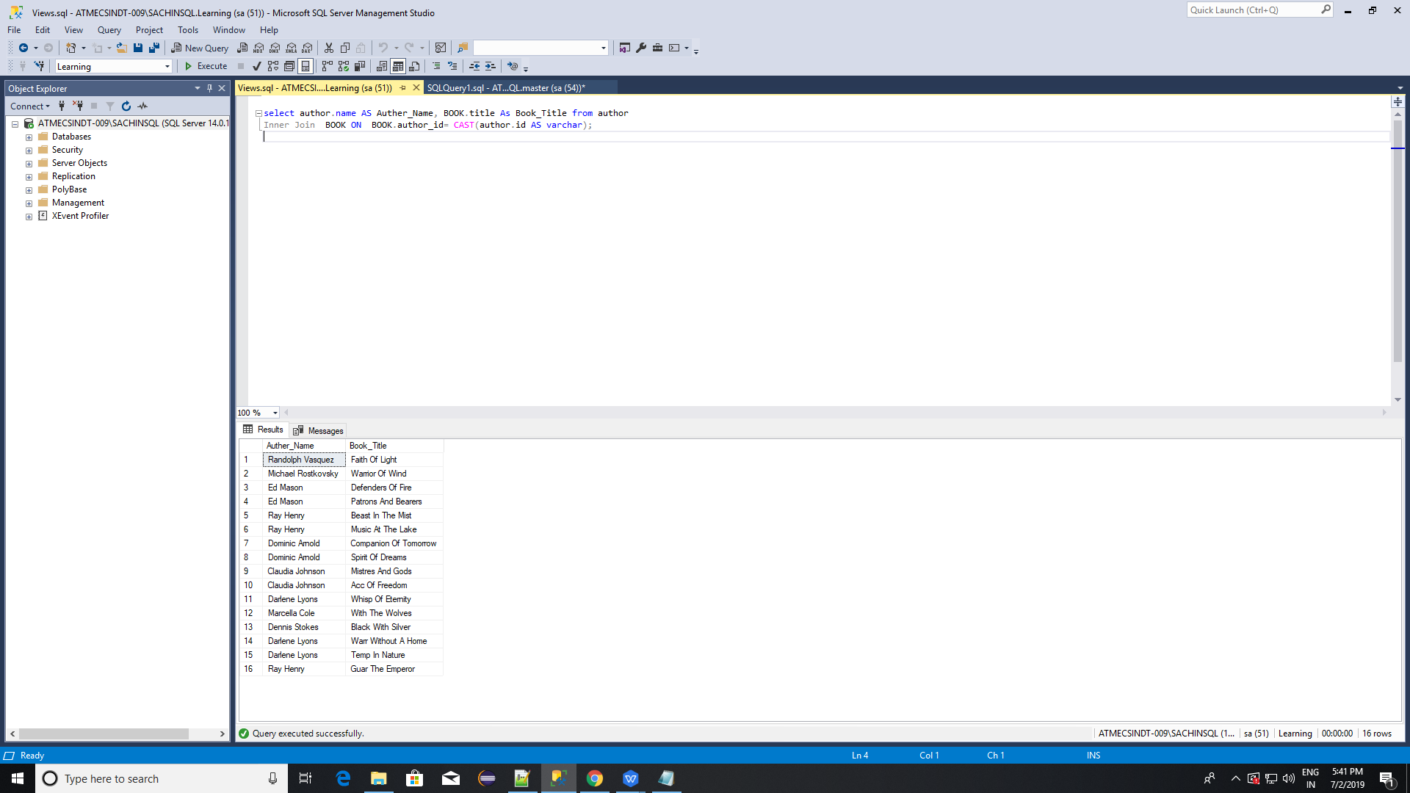

2.Show the name of each author together with the title of the book they wrote and the year in which that book was published.Show only books published after 2005.

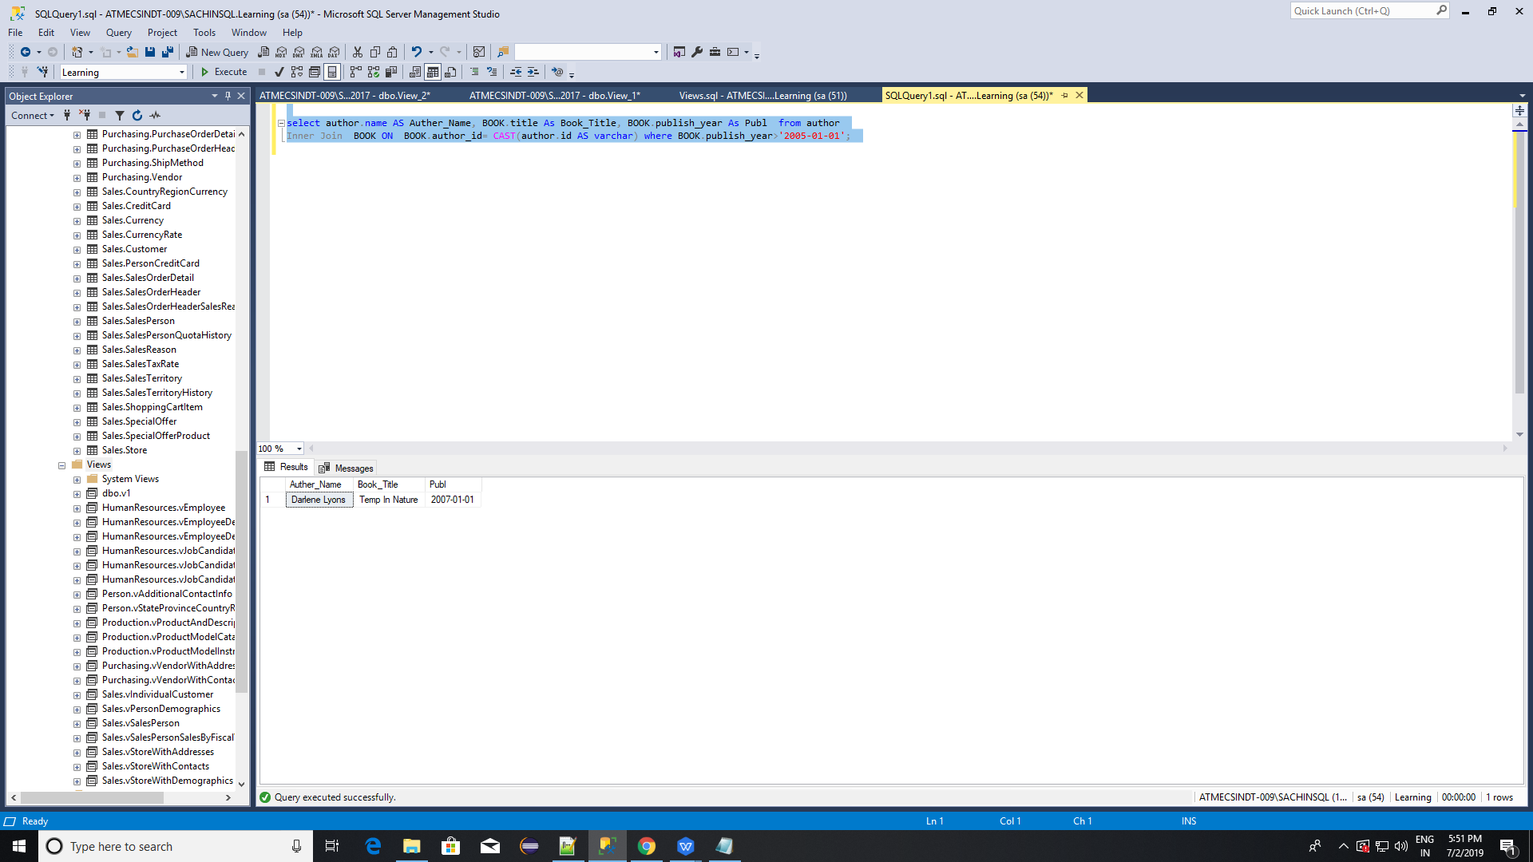

3.For each book, show its title, adaptation title, adaptation year, and publication year.

Consider only books with a rating lower than the rating of their corresponding adaptation. Additionally, show only those books for which an adaptation was released at most four years after the book was published.

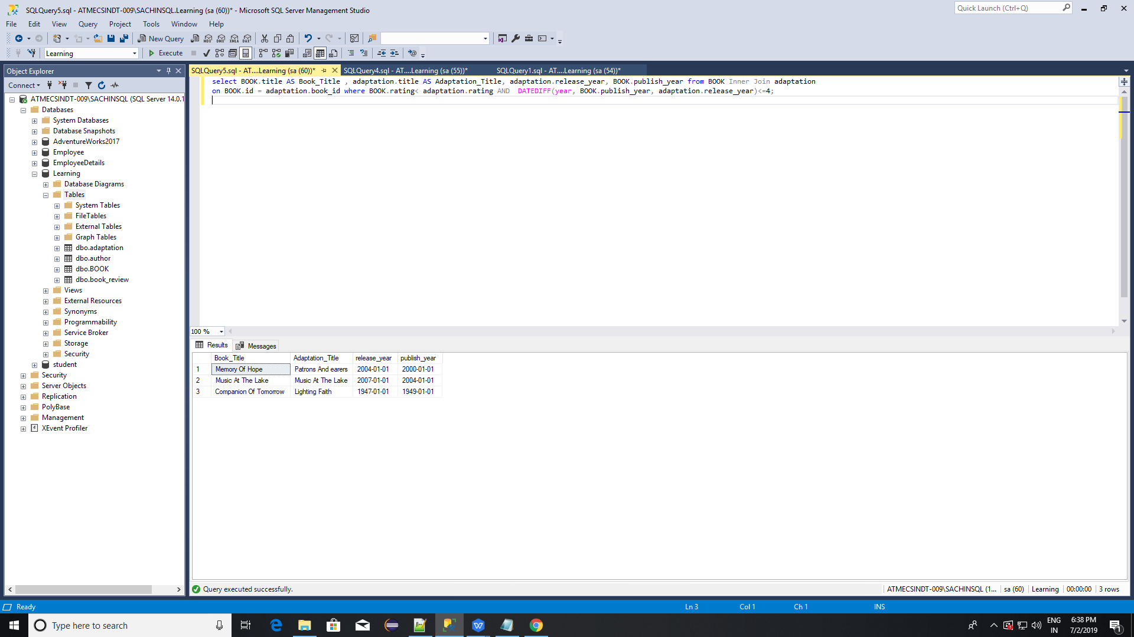

4.Join the author and book tables using an INNER JOIN.

Show the title of each book together with its rating. Consider only those books that were published by authors who are still alive.

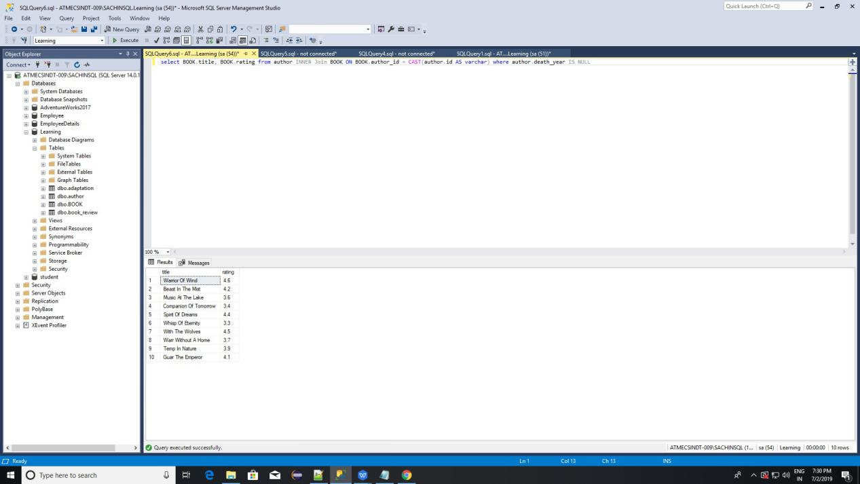

5. Show the title of each book together with the name of its adaptation and the date of the release.

Show all books, regardless of whether they had adaptations.

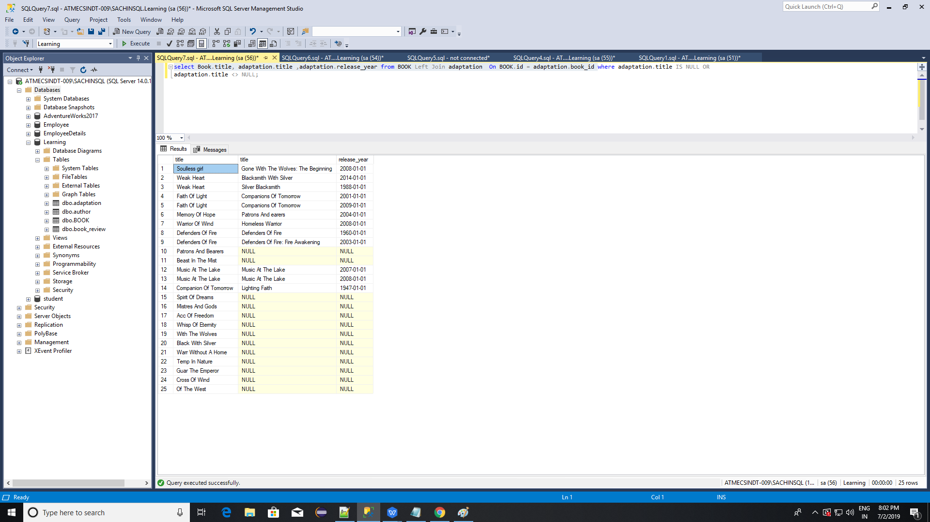

6.Join the book_review and book tables using a RIGHT JOIN. Show the title of the book, the corresponding review, and the name of the review's author. Consider all books, even those that weren't reviewed.

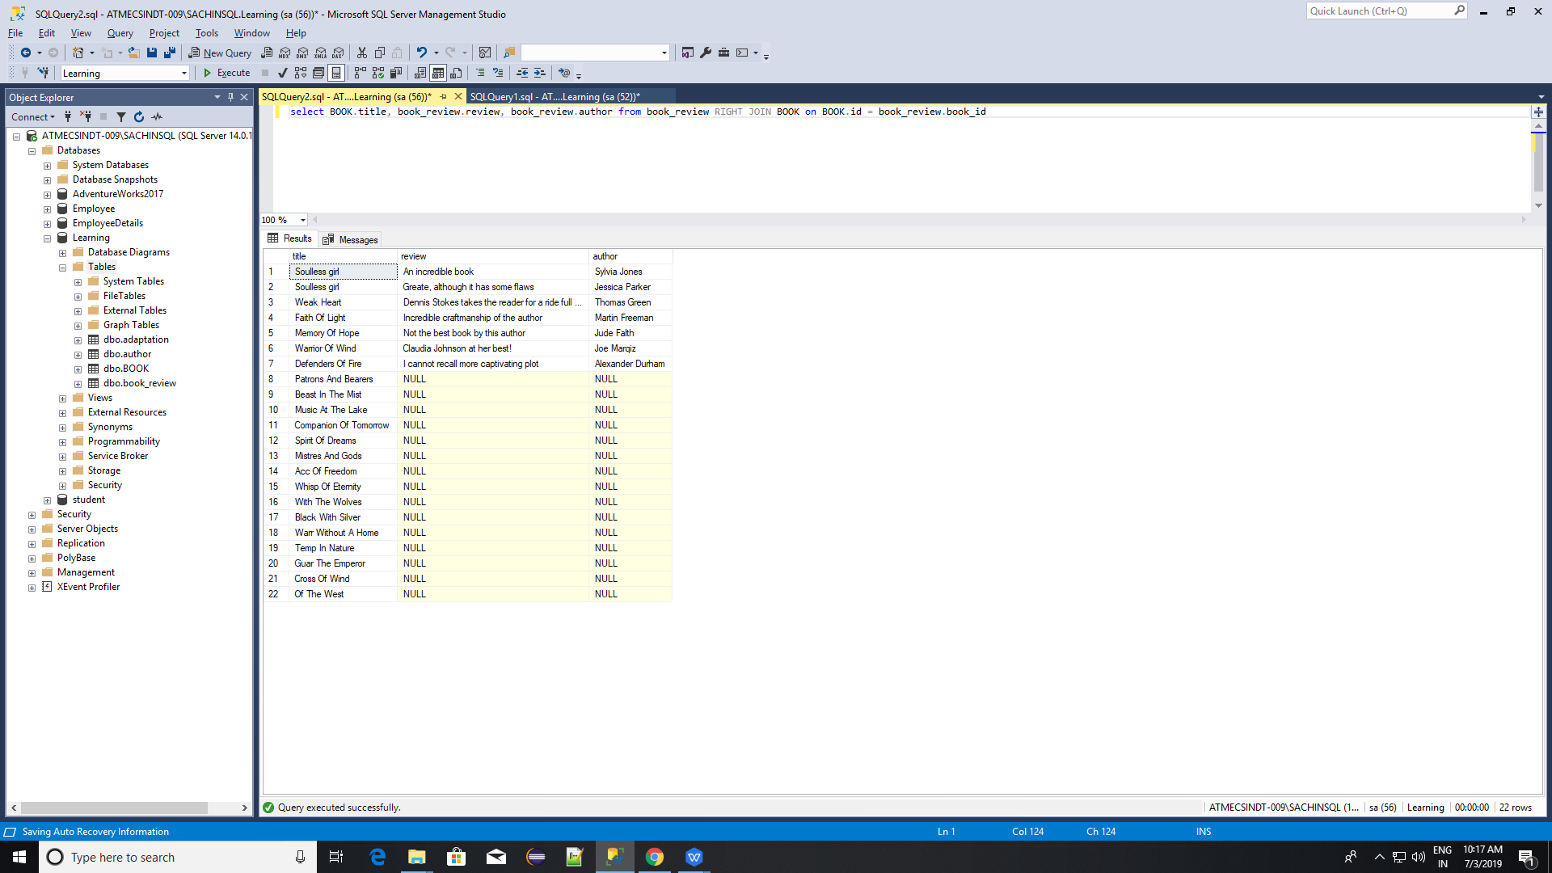

7.Display the title of each book along with the name of its author. Show all books, even those without an author. Show all authors, even those who haven't published a book yet. Use a FULL JOIN.

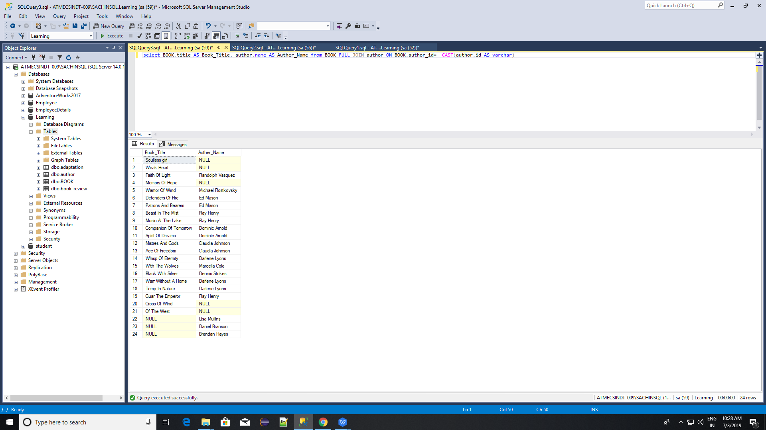

8.Here is the task,match the names of authors to the names of the books they wrote from a list of all book-author pairs correctly.

Generate all possible pairs of book titles and author names. Consider only books whose author's name is Ray Henry.

9.Show all books with their movie adaptations. Select each book's title, the name of its publishing house, the title of its adaptation, and the type of the adaptation.

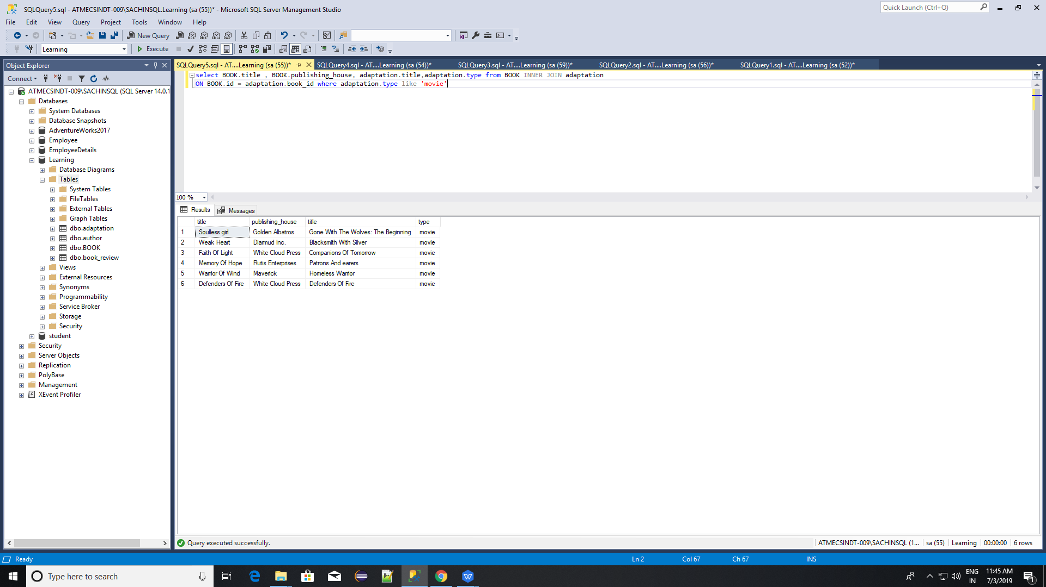

10.Show all information about books that do not have any reviews in the book_review table.

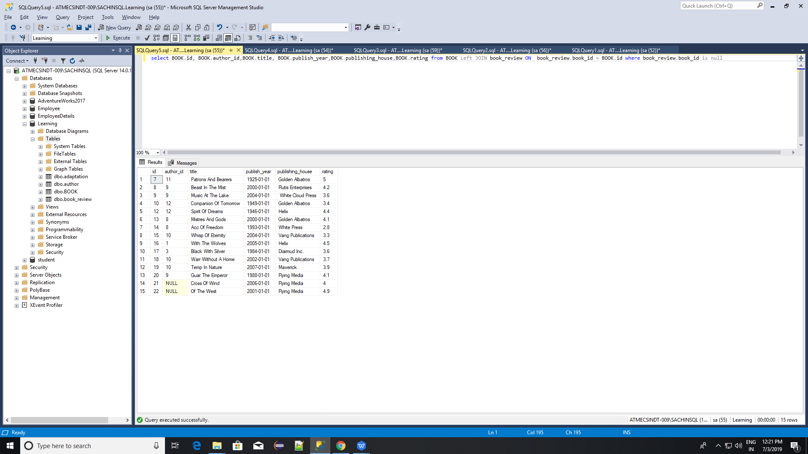

1. Show the title of each book and the name of its author — but only if the author was born in the 20th century. Otherwise, the author's name field should be NULL.

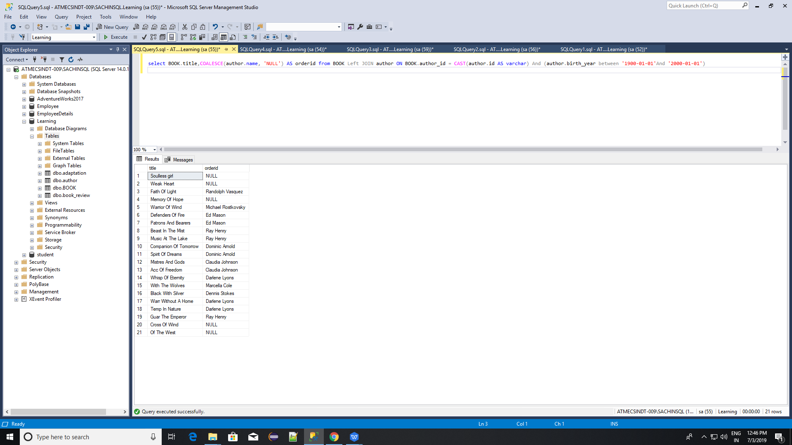

Table for queries(12 to 14)

Bidder Table

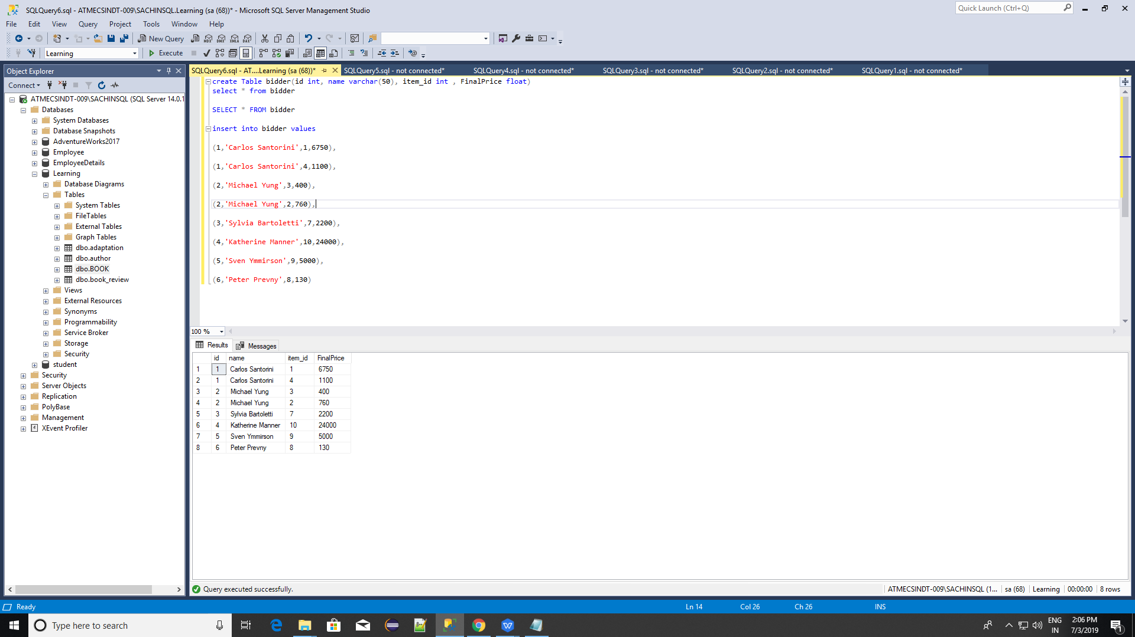

Auction_table

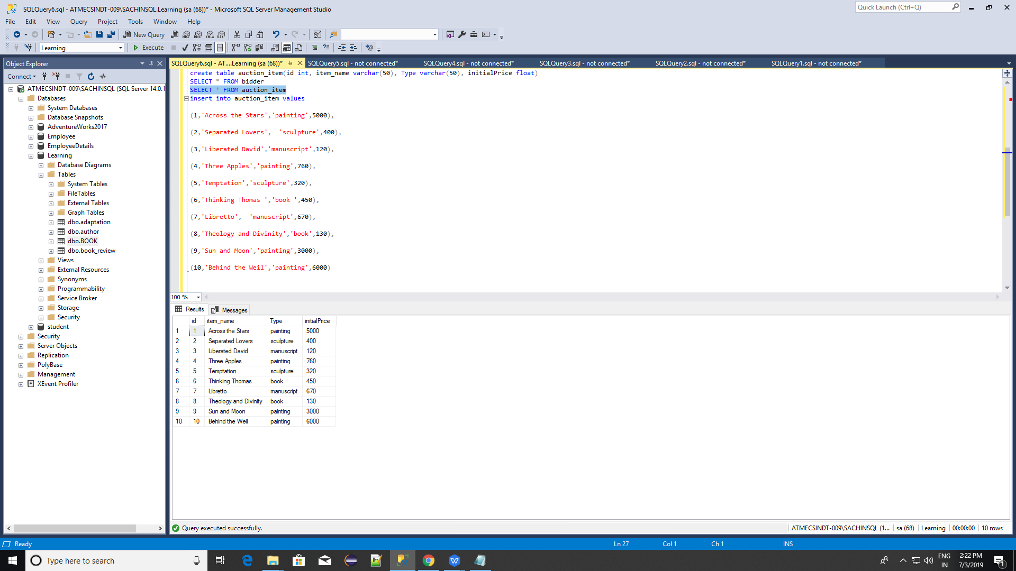

1. For every auctioned item that was sold for a price greater than its initial price, show the item name together with the name of its buyer and the price they paid.

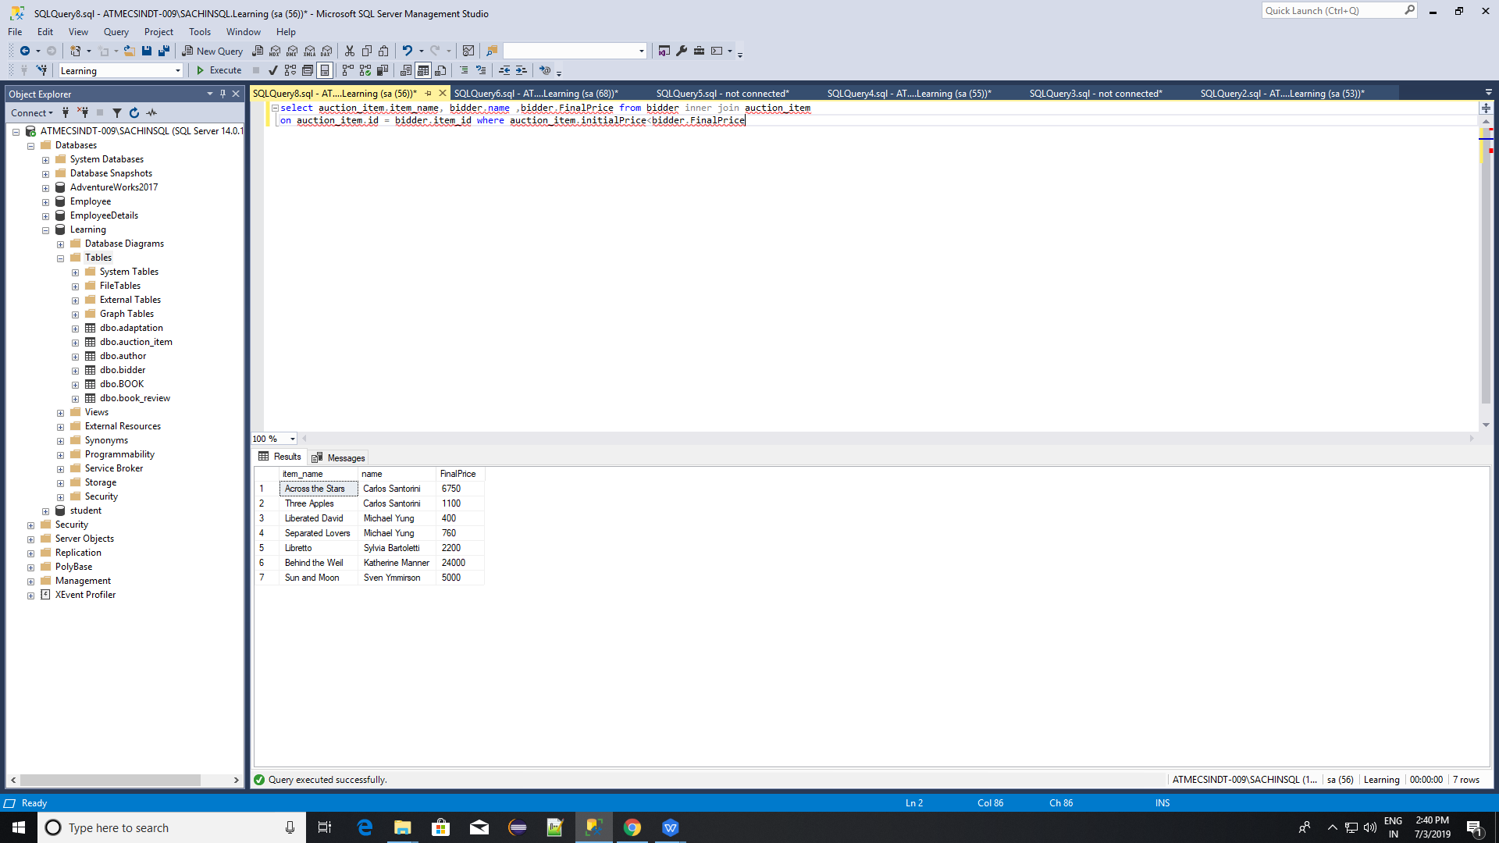

13.Show the name, initial price, and final price of every item with initial price greater than $300.

If the item wasn't sold (there was no bidding person), show the item's name anyway.

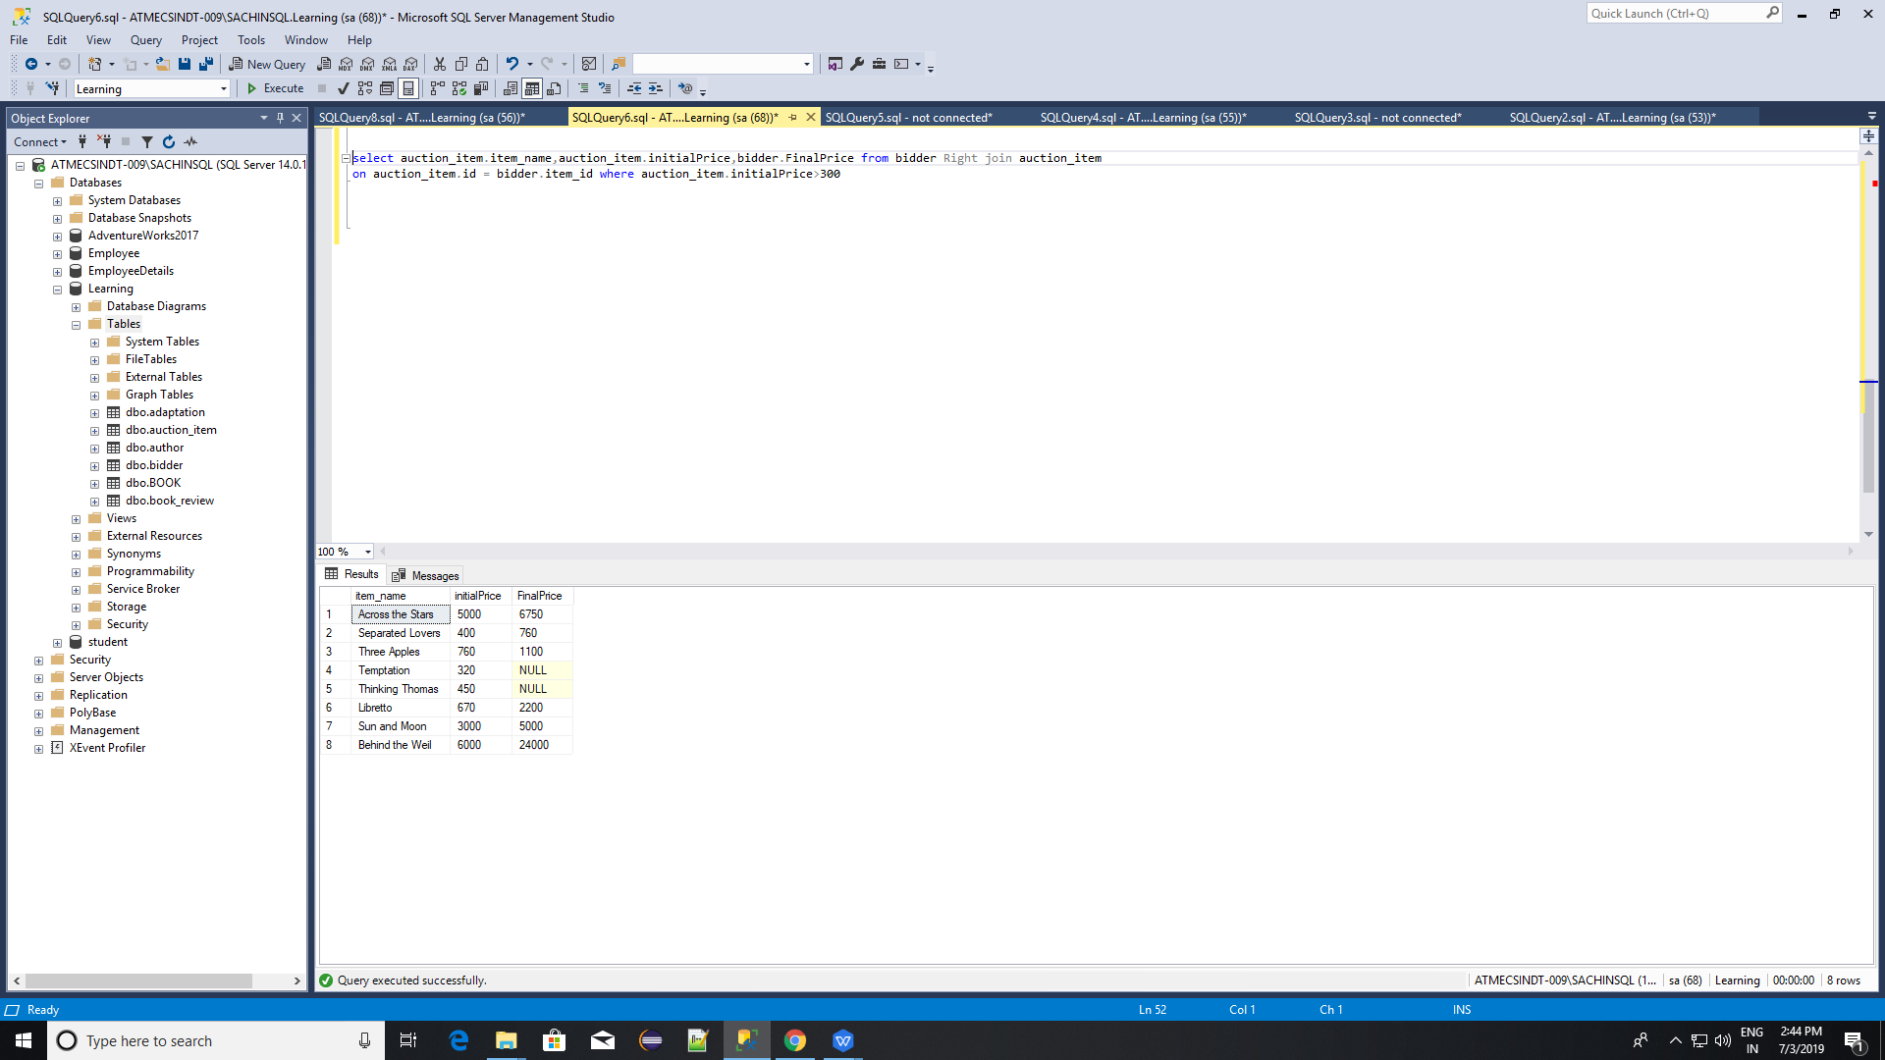

14.Show all information only for those items that weren't auctioned off.

